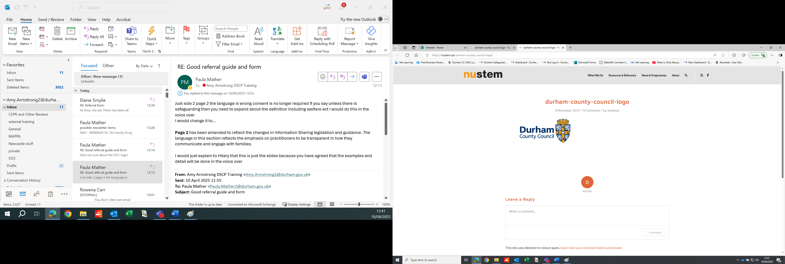

**If a child is in immediate danger dial 999**

**If you are worried about a risk of significant harm to a child, it is essential that you share your concerns by contacting First Contact on 03000 267 979 - Option 3**

This form should be used if you have a **safeguarding concern about a child.**

To make an **‘Online Early Help Request’** go to: [Early help (durham-scp.org.uk)](https://durham-scp.org.uk/practitioners/early-help/) where there are full instructions on how to do this OR: **Telephone the Early Help Triage Workers on 03000 267 979 - Option 4**

If you are unsure about whether to make a referral, please refer to the **Durham Threshold Document** in the **Durham Safeguarding Children Procedures Manual** [Local Resources](https://durhamscp.trixonline.co.uk/resources/local-resources)

To receive a notification about the **outcome of your safeguarding concern**, you must complete in full your address in section 1, the referrer details

Children’s Services

**Safeguarding Referral Form**

Email the completed form to

[**firstcontact@durham.gov.uk**](mailto:firstcontact@durham.gov.uk)

First Contact

**03000 267 979**

|  |
| --- |
| **SAFEGUARDING REFERRALS ONLY** |

|  |
| --- |
| **Information Sharing** |

|  |  |
| --- | --- |
|  | **Have you informed the family that you are making a referral?**  **Yes                   No**  *You should always engage with and explain to the family that you are making a referral and would like their support. You should be transparent about what that means so they understand, and you can hear and consider any issues they raise. The only exception to informing the family would be if doing so would place the child at risk, you should seek guidance from your safeguarding lead if you need advice regarding this.*  **If you have not informed those with parental responsibility, please explain your rationale**  **Are the family agreeing to engage with the pathway to service that you are referring into for example assessment or programme.**  **Yes                   No**  *This does not prevent a referral from being made but is likely to impact on the outcome if the family do not wish to engage with a service especially if this is a voluntary service* |

|  |
| --- |
| **Main Concern** |

|  |
| --- |
| **This section will enable us to monitor main reasons for making a safeguarding concern at point of referral.**  **Please select the MAIN concern you have even if you have multiple worries about a child, which you need to tell us about in the referral form, tick only one.** |

|  |  |  |
| --- | --- | --- |
| **Main reason for safeguarding concern** | **Concern is about impact of a parent/carer** | **Concern is about the child** |
| Ability to care for a child |  |  |
| At Risk/Homeless |  |  |
| Child and Adolescent to Parent Violence and Abuse (CAPVA) |  |  |
| Child Criminal Exploitation |  |  |
| Child Sexual Exploitation |  |  |
| Disability |  |  |
| Domestic Abuse |  |  |
| Emotional Abuse |  |  |
| Extremism/Terrorism/Radicalisation |  |  |
| Harmful Sexual Behaviour |  |  |
| Mental Health |  |  |
| Missing |  |  |
| National Transfer Scheme |  |  |
| Neglect |  |  |
| Non-Agency Adoption |  |  |
| Offending |  |  |
| Physical Abuse |  |  |
| Private Fostering |  |  |
| Section 37 Request |  |  |
| Section 7 Request |  |  |
| Sexual Abuse (child in home) |  |  |
| Sexual Abuse (child outside the home) |  |  |
| Sexual Abuse (Parent/Carer) |  | Not applicable |
| Substance/Alcohol Misuse |  |  |
| Transfer in CP Request |  |  |

|  |  |
| --- | --- |
| **1. Referrer details** | |
| **Name** |  |
| **Role/Agency/Team/Department** |  |
| **Address** |  |
| **Email address** |  |
| **Telephone** |  |
| **Date Completed (dd/mm/yy)** |  |

|  |  |  |  |
| --- | --- | --- | --- |
| **1a. Child’s details** (Please complete Section 2a for further children).**Please gather this information if not known.** | | | |
| **Name of child** |  | **Religion** |  |
| **Also Known As/alias** |  | **Ethnicity** |  |
| **Date of Birth or Expected Date of Delivery** |  | **Immigration status** |  |
| **Age** |  | **Interpreter/signer needed?** | **Yes**  **No** |
| **Gender** | **M**  **F**  **Unknown** | **GP name and practice** |  |
| **Education provider/employer** |  | **Does the child have a disability?** | **Yes**  **No**  **Unknown** |
| **Own agency reference number (e.g. NHS No, UPN)** |  | **State diagnosis if known and any SEN statement if known** |  |
| **Child’s address and postcode** |  | **Does the child have an Education, Health and Care Plan? (EHCP)** | **Yes**  **No** |

|  |  |  |  |  |  |  |  |
| --- | --- | --- | --- | --- | --- | --- | --- |
| **1b. Parent/carer details** | | | | | | | |
| **Adult’s/parent’s**  **full name** | **DOB** | **Gender** | **Address** | **Telephone number** you hold for this family | **Relationship to child referred.**  e.g. mother, father, stepparents, parental partner | **Ethnic origin** | **Do they have parental responsibility?** |
|  |  |  |  |  |  |  | **Yes**  **No**  **Unknown** |
|  |  |  |  |  |  |  | **Yes**  **No**  **Unknown** |
|  |  |  |  |  |  |  | **Yes**  **No**  **Unknown** |
|  |  |  |  |  |  |  | **Yes**  **No**  **Unknown** |
|  |  |  |  |  |  |  | **Yes**  **No**  **Unknown** |

|  |  |  |  |  |  |  |  |  |
| --- | --- | --- | --- | --- | --- | --- | --- | --- |
| **2a. Brothers and Sisters and other related children’s details** | | | | | | | | |
| **Child’s**  **full name** | **DOB**  **EDD** | **Gender** | **NHS No**  **UPN** | **Address** | **Relationship to child referred?** e.g. brother, sister | **Ethnic Origin** | **Mother's full name** | **Father's full name** |
|  |  |  |  |  |  |  |  |  |
|  |  |  |  |  |  |  |  |  |
|  |  |  |  |  |  |  |  |  |
|  |  |  |  |  |  |  |  |  |
|  |  |  |  |  |  |  |  |  |

|  |  |  |  |  |  |  |
| --- | --- | --- | --- | --- | --- | --- |
| **2b. Other family members and important adult’s details** | | | | | | |
| **Adult’s**  **full name** | **DOB** | **Gender** | **Address** | Contact number you hold for this person | **Relationship to child referred.**  e.g. grandparent, aunt, family friend etc | **Ethnic origin** |
|  |  |  |  |  |  |  |
|  |  |  |  |  |  |  |
|  |  |  |  |  |  |  |
|  |  |  |  |  |  |  |
|  |  |  |  |  |  |  |
|  |  |  |  |  |  |  |
|  |  |  |  |  |  |  |
|  |  |  |  |  |  |  |

|  |  |
| --- | --- |
| **3. Family Network** | |
| **Who does the child/young person say are the most important people in their life?** |  |
| **Who do the family say are the people around them who help and support them? How do they help?** |  |

|  |  |
| --- | --- |
| **4. Reasons for referral** | |
| **‘What are you worried about?’**  *What have you seen or heard that you are worried about?’ (*Include as much detail as possible about the behaviour of the adult or child/young person that is causing the worry or harm. Include observations and the detail of who said what to whom*)* |  |
| **What is the impact on the child(ren)?**  *Include what the child/young person has told you or what you have seen or heard the impact to be* |  |
| **‘What do you think is working well and helps to reduce the worries?’**  *For example, consider:*  *What are the times you know of when the parents/carers have looked after the child(ren) well?*  *What are the good things happening in the child/young person’s life that is making life better for them.*  *Who are the people who help?*  *Have there been times when there have been worries and someone has stepped in to make sure that the child/young person has been kept safe? Give details* |  |
| **‘Why do you feel that a social care response is needed?’** |  |

|  |  |  |  |  |
| --- | --- | --- | --- | --- |
| **5. Involvement of other services** | | | | |
| Which other services are **currently or were previously** involved with the child and family (name, agency), if known. This may also include Voluntary and Community Sector Organisations that provide social/community-based services and activities for adults, children and young people i.e. drops in services, community projects, sports clubs, art clubs | | | | |
| **Child(ren) /family** | **Name/agency** | **What support has already been put in place?** | **What impact has this had?** | **Ongoing or ended? Why?** |
|  |  |  |  |  |
|  |  |  |  |  |
|  |  |  |  |  |
|  |  |  |  |  |
|  |  |  |  |  |
|  |  |  |  |  |
|  |  |  |  |  |
|  |  |  |  |  |

Email the completed form to[**firstcontact@durham.gov.uk**](mailto:firstcontact@durham.gov.uk)

Please remember to include all relevant attachments if available.

Chronology

Child Exploitation Risk Assessment (CE Matrix)

DASH Risk Assessment

Graded Care Profile 2

Home Environment Assessment

Family Engagement Risk Assessment

EHCP

Signs of Safety Harm Matrix

Other (please state)